MATH 282 Assignment #2

Computational methods for integration

**Due by 10pm on Monday, October 24, 2022**

**Total marks: 25**

Late assignments submitted by 10pm on Tuesday, October 25, 2022 will receive 75% of the mark that they would have received. Any assignments submitted after that will receive a mark of 0 and no feedback will be provided.

Assignment #2 can be completed in groups of 1-3 students of your choosing. If you are working in a group, you must email me ([michael.grzesina@saskpolytech.ca](mailto:michael.grzesina@saskpolytech.ca)) by 10pm on Monday, October 17, 2022 with the names of your group members. Any plagiarism or other academic misconduct will result in a mark of 0 for all offending parties and possible further consequences.

# Submission Instructions

If you have a paper copy (handwritten) of any of your answers, submit it to Michael or to the drop box in room 242.

* Your names and CST numbers must be on the pages
* Answers should be clearly labelled with the question number
* Answers must be legible

For submitting files:

* Create a folder named ***[polytechusername][polytechusername]*math282a2**, where ***[polytechusername]*** are the SaskPolytech usernames of your group members.
* For programming questions:
  + Use the package **math282a2** for all source code
  + Include only the source code (**.java** files)
  + Make sure that all files have proper comments and follow the CST programming style guide
  + Ensure that all source code files are submitted (so the program can be compiled and run from the files submitted)
* When done, create a compressed folder named   
  ***[polytechusername][polytechusername]*math282a2.zip**
* Submit the compressed (zipped) file to the Assignment #2 Dropbox Folder in the MATH282 online course material for MATH 282 (under Assessments > Dropbox).

1. *[12 marks]* Use each of the following 4 rules (algorithms given in class) to calculate the following integrals to a relative precision of at least 0.000001 and a maximum loops of 30. (Consider starting with a precision of 0.001 for a quicker calculation. Once your code is working, use the higher precision.) Time how long it takes for each method to calculate each integral, using code similar to the following Java segment:

System.out.println("Trying simple left rectangle rule for equation 1(a)");  
long time1 = System.currentTimeMillis(); // or System.nanoTime()  
double result = f1a.integrateLeftRectangle(0.0, 2.0, 0.001, 30);  
long time2 = System.currentTimeMillis(); // or System.nanoTime()  
System.out.println(result + " found in " + (time2 - time1));

The four integration rules (each to have its own method to implement):

* The simple version of the left rectangle rule (see **Left Rectangle Rule Algorithm.docx**)
* The efficient version of the left rectangle rule (see **Left Rectangle Rule Algorithm.docx**)
* The trapezoid rule – for full marks, implement all efficiencies (see **Trapezoid Algorithm MATH282-CST.docx**)
* Simpson’s rule – for full marks, implement some efficiencies

The integrals follow:

* 1. 
  2. The integrals assigned to you (or *each* member of your group) in **A2Q1Integrals.docx** in the folder **Assignments\a2q1\** subfolder in the MATH 282 OneDrive folder
  3. 

*Notes:* log2(*x*) means “the base-2 logarithm of *x*” – in other words, the power of 2 that produces the result *x*, or the value *y* such that 2*y* = *x*. For instance, log2(1024) = **10**, since 2**10** = 1024.

Most programming languages have a log method, but the method may not allow you to specify the base; it may always do natural logarithms (to the base *e*), or base-10 logarithms. To create base-2 logarithms from any other base, use the following formula:

log2(*x*) = log(*x*) / log(2)

You can check that your log2(*x*) function works by comparing it to Excel’s **LOG** function. The Excel formula **=LOG(*value*, *base*)** will calculate the logarithm of a given value to a desired base. For instance, **=LOG(1024, 2)** results in **10**.

Submit all required source code (which should show the required output when executed), and submit a Word document or text file with the output produced for this question only.

1. *[7 marks]* In the **Assignments\a2q2\** subfolder in the MATH 282 OneDrive folder, you will find the Excel workbook **A2q2Calculations.xlsx**. On the **Documentation** worksheet, fill in cells C2, C3, and C16 with your name(s), username(s), and the requested result from question #1(d) *[if you are already done question #1(d) – if not, you can start question #2 and go back and fill in the result later, or use the result from another source like Wolfram|Alpha]*.

From the **Assignments\a2q2\** subfolder in the MATH 282 OneDrive folder, print the Word document **A2q2 graphs.docx** or just edit the document directly. Answer the questions on the printout (or in the edited document), filling in the appropriate worksheets in the Excel workbook where requested.

To submit, save the completed Excel workbook in your assignment folder and include the completed Word document or submit a paper copy of the Word document.

1. *[6 marks]* So far, we have only looked at integrating functions where f(x) is positive. When a function also has negative values in the region being integrated, there are two possible interpretations:
   1. The area below the *x*-axis (where *f*(*x*) is negative) should be subtracted from the area above the *x*-axis (where *f*(*x*) is positive). We are interested in the *net* area.
   2. The area is always positive, so the area below the *x*-axis should be added to the area above the *x*-axis. We are interested in the *total* area.

Both of these interpretations can be valid – it depends on what kind of answer we want. For instance, suppose *f*(*x*) represents the speed of a car travelling on a highway. A negative speed indicates that we have turned around and are going in the opposite direction (back towards our starting point). The integral of *f*(*x*) is the distance that the car has travelled. The two interpretations are as follows:

a. When speed is negative, we are going back towards the starting point, so we should subtract the distance travelled when the speed is negative from the distance travelled when the speed is positive. We want to know how far we end up from our starting point.

b. Even when speed is negative, the car is still moving – it has only changed direction. If we want to find out the total distance the car has travelled in either direction (the total distance added to the odometer), we should add the distance travelled when the speed is negative to the distance when the speed is positive.

For example, consider the function *f*(*x*) = 0.025*x*4 - 0.175*x*3 - 0.15*x*2 + 1.8*x*. Suppose we wish to integrate *f*(*x*) from *x*=0 to *x*=6. As shown below, this function is positive from *x*=0 to *x*=4, and negative from *x*=4 to *x*=6. Then the two interpretations of the integral are as follows:

a. If we consider the area below the graph as negative, then the net area is 5.12 - 1.34 = 3.78.

b. If we consider the area below the graph as positive, then the total area is 5.12 + 1.34 = 6.46.

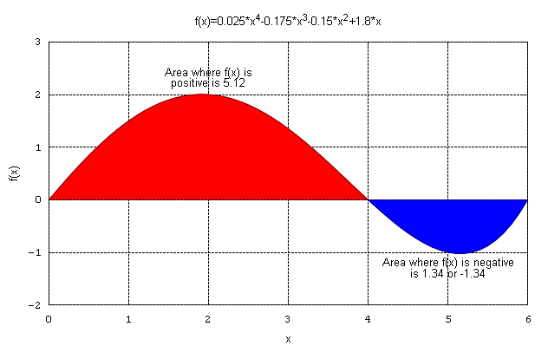

Change your code for *one* of your integration rules so that it takes a Boolean variable net. If net is true, the function should calculate the integral as the net area. If net is false, the function should calculate the integral as the total area. Test your results by calculating the integral of   
*f*(*x*) = 0.025*x*4 - 0.175*x*3 - 0.15*x*2 + 1.8*x* from *x*=0 to *x*=6 using each setting and a relative precision of 0.000001.

Submit all required source code (which should show the required output when executed), and submit a Word document or text file with the output produced for this question only.